FISCal Service Center Ticket Request 1.0

Supplemental Job Aid

Date: 06/28/2019
Target Audience: All FISCal Users
Purpose: This supplemental Job Aid provides FISCal users the steps to submit a Ticket Request to the FISCal Service Center (FSC) using either a Microsoft Outlook template or a PDF form. FISCal users can access the Ticket request options from the public website or from within the FISCal PeopleSoft application.
• SECTION 1: Submit Ticket Request from FISCal website.
Part 1: Submit a Ticket request for Microsoft Outlook users.
Part 2: Submit a Ticket request for Non-Microsoft Outlook users.
• SECTION 2: Submit Ticket Request from within FISCal PeopleSoft Application

SECTION 1: Submit Ticket Request from FISCal website
Part 1: Submit a Ticket request for Microsoft Outlook users
Step 1: From the FISCal homepage, click the Access FI$Cal button. On the Access FI$Cal page, click the FSC Email Ticket Template (Outlook Users) link. A Microsoft Outlook pre-populated email message will open.

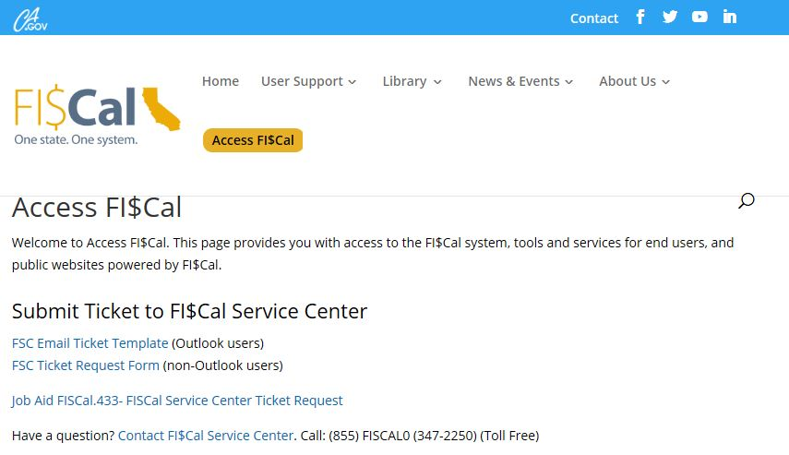
Step 2: All fields are required and must be completed.

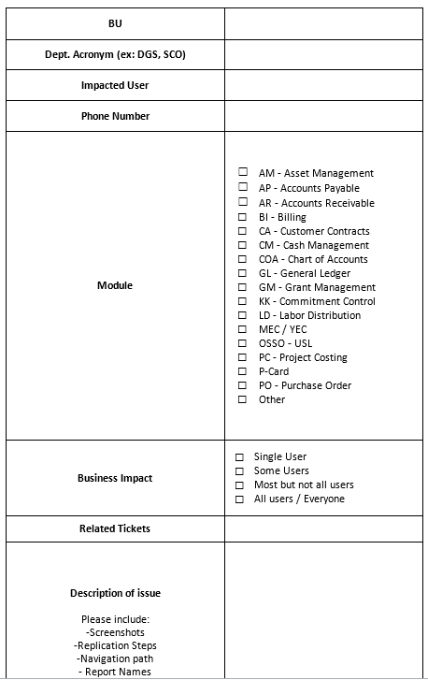

Step 3: In the Subject field. Enter your department’s Business Unit (BU), department acronym and brief description of issue. For example: “0840, DSC, can’t access FISCal application”.

Step 4: Enter the Business Unit (BU). Enter a 4-digit numeric value e.g., "0840".

Step 5: Enter the Dept. Acronym. Enter a text value e.g., "DGS, SCO, etc.".

Step 6: Enter the Impacted User. Enter first and last name of impacted user.

Step 7: Enter the Phone Number. Enter a number value e.g., "916-576-4560".

Step 8: Select Module Impacted. Select a value e.g., “GL-General Ledger”

Step 9: Select Business Impact, choose one option.

Step 10: Enter any Related Tickets.

Step 11: Enter a detailed Description of issue.

Step 12: Select one Availability checkbox(s) for best time to contact.

Step 13: Select one Preferred Method of Contact.

Step 14: Attach any relevant Screenshots, Replication Steps, Navigation path, Report Names, Relevant Files (Voucher Spreadsheet Upload, Reconciliation Reports, etc.) to this email message.

Step 15: Click the SEND button in your Outlook.

SECTION 1: Submit Ticket Request from FISCal website
Part 2: Submit a Ticket request for Non-Microsoft Outlook users.
Step 1: On the Access FI$Cal page, click the FSC Ticket Request Form (Non-Outlook users) link. A PDF form will open on your desktop.

Step 2: All fields are required and must be completed. Please attach this form via e-mail to: fiscalservicecenter@fiscal.ca.gov. For further assistance please call: (855) 347-2250.

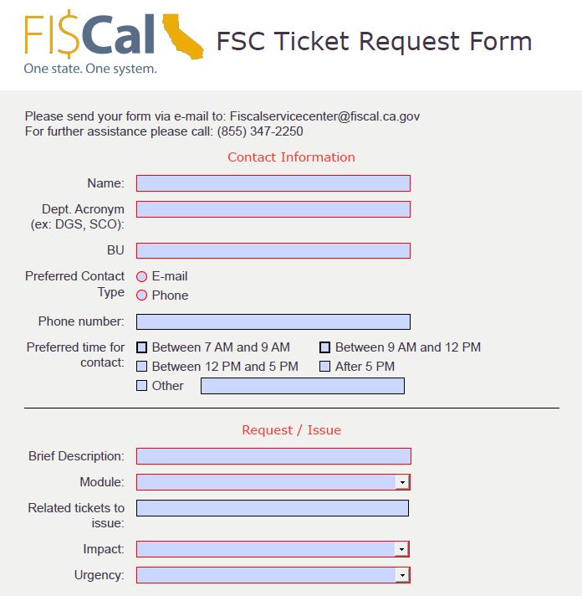

Step 3: Enter your Name. Enter a text value e.g., “Jane Doe”.

Step 4: Enter your Dept. Acronym. Enter a text value e.g., "DGS, SCO".

Step 5: Enter your Business Unit (BU). Enter a 4-digit numeric value e.g., "0840".

Step 6: Check radio box for Preferred Contact Type, check E-mail or Phone.

Step 7: Enter your 9-digit Phone number. Enter a number value e.g., "916-987-4561".

Step 8: Check one option for Preferred time for contact. Or enter specific time in Other field.

Step 9: Enter Brief Description of your issue.

Step 10: Select dropdown option for Module. Select a value e.g., “AR-Accounts Receivable”

Step 11: Enter text for any Related tickets to issue.

Step 12: Select dropdown option for Impact.

Step 13: Select dropdown option for Urgency.

Step 14: Enter text for -Steps taken, -Report Names, or -Any additional Information

Step 15: Attach this completed PDF form along with any relevant screenshots or files and to an email and send to: fiscalservicecenter@fiscal.ca.gov

SECTION 2: Submit Ticket Request from within FISCal PeopleSoft Application
Step 1: Log into to the FISCal application. The links for selecting how to send the FSC Ticket Request are displayed under the Service Center.
Step 2: Follow SECTION 1: Part 1 or SECTION 1: Part 2.

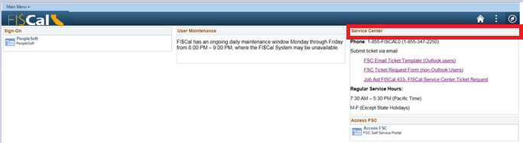

You have completed the FISCal Service Center Ticket Request Job Aid.

